Number system - Hexa-decimal number (Base-16)
Any numerical value (number) can be represented in any of the following number system.
Number Base | Number system
Base 2 | binary | The common representation of data in computer is a string of bits, using the binary numeral system (Base-2).
Base 8 | octal
Base 10 | decimal | The most familiar representation of numbers is in base 10 systems. Eg 12345.
Base 16 | hexadecimal | Binary strings (01000001) are long and hard for human programmers to read. To simplify this, programmers split a byte in half (two 4-bit sections called nibbles) and convert them into Hexadecimal (Base-16). It is convenient shorthand notation to talk about binary numbers. Hexadecimal is also commonly used to represent computer memory addresses.
Hexadecimal is a number system that uses 16 symbols to represent numbers.
- Hexadecimal uses the symbols 0–9 to represent the values 0–9.
- It uses the letters A–F to represent the values 10–15. In hexadecimal, when you reach the decimal number 10, you switch to letters A through F because a single digit can hold any value up to 15.
- Each digit represents a decimal value. For example, D is equal to 13 in base 10.

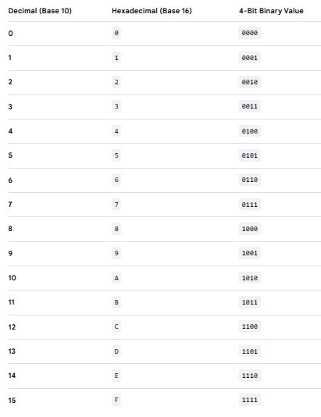

Conversion between number systems
Decimal to Hexa-decimal conversion | Hex to decimal conversion
Identify the group of 4 bits each. Fill the partial group with 0’s on outside. Then replace each group with the corresponding hex digit. | hexadecimal number (Base-16) 0x2AF3 is equal to 10,995 decimals (base-10).
  0011 | 1010 | 0101 | 0110 | . | 1110 | 0010 | 1111 | 1000
  3 | A | 5 | 6 | . | E | 2 | F | 8
  Base-16 | 2 | A | F | 3
  base-16 to base-10 | 2×16³ | A×16² | F×16¹ | 3×16⁰
  base-16 to base-10 | 2×16³ | 10×16² | 15×16¹ | 3×16⁰
  base-16 to base-10 | 2x4096  =8192 | 10x256  =2560 | 15x16  =240 | 3*1  =3
  Base-10 | 10,995

8-Bits (1byte) | 1 | 1 | 1 | 1 | 1 | 1 | 1 | 1
Base -2 place holder | 1*2⁷ = (128) | 1*2⁶ = (64) | 1*2⁵ = (32) | 1*2⁴ = (16) | 1*2³ = (8) | 1*2² = (4) | 1*2¹ = (2) | 1*2⁰ = (1)
Decimal value | 255
Hexadecimal value | 0xFF

